Oracle Installation Guide
Version 21
For Oracle 10gR2 and Oracle 11gR1
June 2009



Copyright 2005 – 2009 Robert Schudy
Permission granted for any use of Boston University

With contributions from Adam Arakelian, Dhananjay Kulkarni, and Warren Mansur

Table of Contents
Introduction 3
Installing Oracle 7
Step 1: Creating an OTN Account 7
Step 2: Downloading Oracle 11g 12
Step 3: Unzipping Oracle 19
Step 4: Installing and Configuring Oracle 22
How to Shut Down and Start Up Oracle 36
Configuring Oracle Startup Options 37
Appendix A: Installing and Enabling the Microsoft Loopback Adapter 38
Appendix B: Installing Oracle 10g Express Edition 44
Introduction 44
Requirements 44
Installation (Windows) 44
Installation (Linux) 49
Starting the Database (Windows and Linux) 50
Appendix C: How to reset your SYSTEM password on Windows 52

Introduction

These instructions are used by students enrolled in the Master of Science in Computer Information Systems and other Computer Science Department programs in both on-campus and online programs. In some places these instructions say that you should contact your instructor. Online students should normally contact their facilitator first.

The document begins with a discussion of Oracle, connecting to the Oracle web site, creating an Oracle Technology Network account, downloading either an Oracle 10g Release 2 or Oracle 11g Release 1 zip file, unzipping it and installing Oracle. We continually update this document; please letting us know of problems you encounter or questions not answered.

The examples in the main document are for the Microsoft Windows family, including Windows 2000, XP, and Vista. If you are installing on an operating system other than the 32-bit Windows family, such as Linux or Solaris, then follow these instructions to join OTN, except download the version of Oracle for your platform rather than the Windows version. The Quick Installation Guide and the full Installation Guide for your operating system can be found in the Install directory created when you unzip the file you will download as part of these instructions.

These setup instructions are for Oracle 10g Release 2 and for Oracle 11g Release 1. The installation instructions are very similar, and the screen shots in these instructions are from installations of both Oracle 10gR2 and Oracle 11gR1. Oracle has maintained upward compatibility for SQL between Oracle versions for many years. If you cannot install Oracle 10g or 11g on your own machine, and you have ready access to an Oracle installation you may be able to use it. MET CS579 and CS669 require Oracle 8i or later, and MET CS779 requires Oracle 9i or later, unless you wish to do a term project using Oracle Grid or another feature only available in the latest releases. If the computer on which you wish to install Oracle is running the Microsoft Vista platform we recommend that you install the special version of Oracle 10g Release 2 for Microsoft Vista. Students have encountered spurious errors when running Oracle 11gR1 on Microsoft Vista without Service Pack 1 (SP1)

If you have difficulty installing Oracle we have an advanced technology solution, which is to use a virtualization of a Windows XP machine with Oracle already installed. Virtualization is emerging technology that allows us to efficiently run a virtual machine on the machine that you already have. We use Microsoft’s virtualization software, which is free of charge to students. The virtual image is too large for a CDROM, so you will need to either download it from our web site, or we can overnight you a DVD containing the image. We recommend that you have one gigabyte or more of physical RAM to run the Oracle virtualization.

Also included are instructions for setting up Oracle Express Edition, a smaller version of the full product. Although it has limitations with regard to the amount of memory, size, and number of tables allowed, it is quite usable for our classes, and it introduces a much lighter load on your computer. We recommend that you install Oracle 10g Express Edition for classes except CS674 Database Security, which makes use of the Enterprise Manager. You should also install the Enterprise Edition if you plan to do a term project with large databases, Oracle Grid, Enterprise Manager or other features that are not in the Express Edition. Oracle Enterprise Edition requires no more resources than Oracle Standard Edition.

Oracle is continually updating Oracle.com, so the screens that you see on Oracle.com will probably be a little different than what is shown in this document. If you can’t determine how to proceed because what you see is too different, or if something goes wrong ask your instructor what to do. Good luck, and have fun!

Oracle Overview

About Oracle | We will make extensive use of Oracle in this class. We have chosen Oracle instead of IBM DB2, Microsoft SQL Server, MySQL, or one of the numerous other commercial or open source databases because for three decades Oracle has led the industry in the development and delivery of advanced database technology and standards. Oracle has essentially all of the advanced features in any relational or object-relational database management system. Because of this, many of the new ANSI/ISO SQL standards are based on Oracle, so when you learn Oracle you are mainly close to the portable standards. Unlike MSSQL Server, Oracle runs on all common platforms from huge symmetric multiprocessors to ordinary PCs. Oracle is also very scalable, and it supports both clustering and grid computing to surpass the performance and reliability of any single platform. Oracle is the standard by which other database management systems are measured, and when you learn to use Oracle your skills will transition well to other database management systems.  Oracle runs on ordinary machines. Oracle runs on the largest multiprocessors, but Oracle also runs very well on ordinary PCs and recent Macintoshes. PCs are the most common Oracle hardware platform, and there are Oracle versions for many PC operating systems, including the Windows family and Linux.  The following instructions are for the default configuration, the easiest of the Oracle installations. Oracle is very flexible and can be configured to use less or more in the way of machine resources. There are suggestions in the instructions below for minimizing hard disk usage. The easiest way to minimizing the use of resources on your machine is to download and install Oracle Express, which requires about half the RAM of the other Oracle editions. Oracle 10gR2 Express Edition is available, but Oracle 11gR1 Express edition may not yet be available. If you want to run Oracle on a platform other than Windows, please see the platform notes at the end of the document or contact your instructor for assistance.
Hardware Requirements | The following information is based on best-practices.  - At least 256 megabytes of RAM. 512 megabytes is easier, but it is not required for the Express Edition.  - At least three gigabytes of free hard disk space before the download  If these hardware requirements are a problem for you please contact your instructor for assistance.  Oracle can be installed in Personal, Standard, Enterprise, and Express versions. The main difference between the versions is licensing. Personal Oracle is fully functional and is the version that is normally used by application developers. The standard version is normally used by mid-sized enterprises. The Enterprise version includes the Enterprise Manager. The RAM and hard disk footprints of the Enterprise version are not significantly different than that of the Personal or Standard version. The RAM footprint of the Express version is about half that of the other three.
Common Platforms | Oracle runs on all common platforms, including the Windows family, the latest Macintosh operating systems, several Linux variants, and several Unix variants. Oracle supports the features that we use in our courses on all platforms, and it doesn’t matter what platform your Oracle runs on. You will connect to Oracle using the SQLPlus client and other Oracle client applications. Oracle can be on the same machine as the client or on another machine on the same LAN or anywhere on the Internet. Starting around midterm of Fall 2007 we will have Oracle virtualizations running on a server at BU, so if you have difficulty with your Oracle install we can provide you with access to your own copy of Oracle over the Internet.
Platform Independence | Oracle behaves the same regardless of the platform except for database size limitations and performance. Your exercises will behave the same way across all Oracle platforms.

Preparations and Setup | You can obtain a copy of Oracle by downloading Oracle from Oracle.com or by obtaining an Oracle 10GR2 or 11gR1 CD-ROM from the Department. If you experience downloading difficulties please contact Chris Hutchison-Jones in the Department (chj@bu.edu). You will receive a response normally within 24 hours and a copy of the Oracle database CD-ROM will be sent to you by overnight delivery. Most people with broadband should be able to complete the download and install the program with minimal difficulty. If you are installing from a CD-ROM, you will not need the instructions in the following Parts 2 through 4, and you can skip directly to Part 5.  Setting up Oracle is not like setting up an application. Oracle and other DBMS are more deeply integrated with the operating system than ordinary applications. Oracle installs do many more things than application installs. The installer will check for the many problems that can occur on your system. Oracle installations on unmodified environments usually occur without significant issues, but many things can go wrong, particularly with modified operating system environments. Expect the unexpected, and don’t feel embarrassed if something unexpected happens. Unexpected events are common for database installations. Just contact your instructor, who will help you.

Oracle Express Edition versus the Full Product | The Express Edition is a smaller version that places limits on the size of the database, the number of connections that may be opened, and the number of tables.  For MET courses, we have found that the Express Edition is suitable and has the advantages of a much smaller load on the computer and a simpler installation. Oracle Express Edition does not come with the full SQLPlus client, which comes with the other editions. You can download and install SQLPlus separately; the SQLPlus client works fine with Oracle Express. Oracle Express does not come with the Enterprise Manager, for which you will need to install Oracle Enterprise Edition.  Instructions for installing the Express Edition are located in Appendix B.

Installing Oracle

Step 1: Creating an OTN Account

Introduction | This section guides you through the sub-steps to create your own Oracle Technology Network (OTN) account. Before you can download Oracle you must create and login to an Oracle Technology Network account.

Log On to OTN | Logging onto Oracle Technology Network  Go to http://www.oracle.com. Oracle is constantly updating their web site, so what you see may be different than the following, but it will be similar.  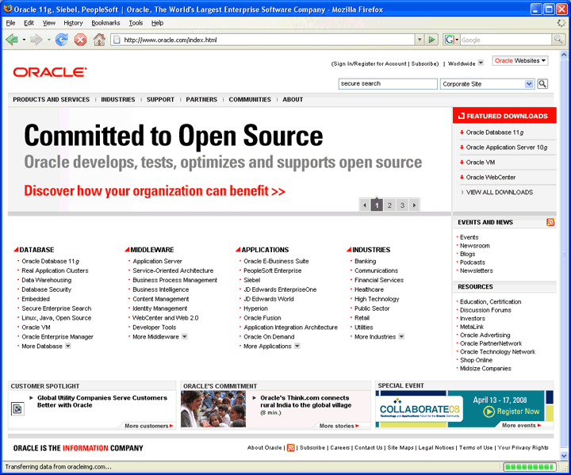  Click on the “TECHNOLOGY NETWORK tab at the top or just enter http://www.oracle.com/technology into your browser and you will see something like this:  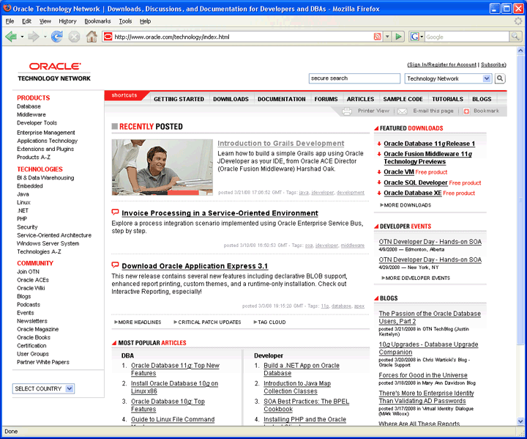  Click on “Sign In/Register for Account” in the upper right hand corner. You should see something like this:  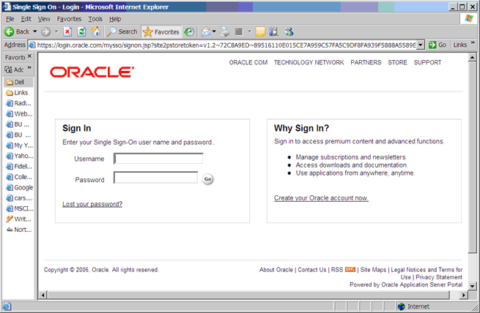  Click on “Create your Oracle account now” at the bottom of the right box. You should see something like the following. Enter your new user name and password.

Sign Up For an Account | Sign Up for your Oracle OTN Account  - Click on the Sign up link at the bottom, then click Go. You should see something like the following page.  - Type in your email address and a password for your new OTN account.  - Click Confirm. Note that Oracle uses the portion of your email address to the left of the "@" sign as your OTN user name. If the site complains that the user name is already taken, you will need to use another email address, or create a new one. It is easy to create a new email account at sites like yahoo.com. I used such a Yahoo email address below.  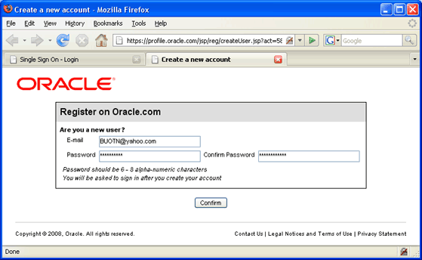  You will then be presented with a long form asking for your name, address, etc. Complete the form and click "continue." You will find yourself logged into the OTN, as follows.  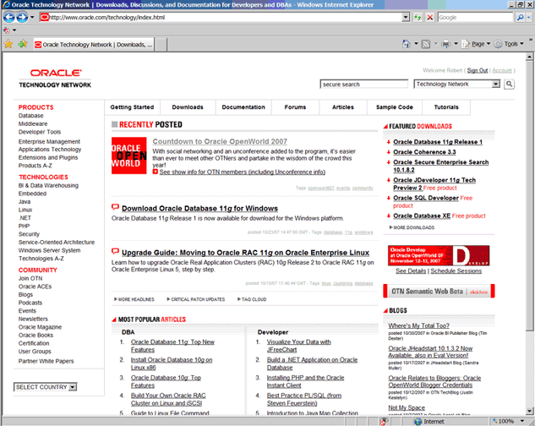  If you look in the upper right hand corner you should see your first name and “Sign Out”, which indicates that you are logged onto OTN. Congratulations!

Step 2: Downloading Oracle 11g

Introduction | The following instructions guide you through the sub-steps to download the Oracle zip file appropriate for your operating system.

Download Oracle | You can get to the Oracle Technology Network directly by following this link:  http://www.oracle.com/technology/index.html  Select in the following order from the OTN home page above:  - Downloads tab;  - then Database  This will take you to a page of Oracle database downloads for different platforms and different Oracle versions. Oracle Database 11g Release 1 is listed first, followed by Oracle Database 10g Express Edition, followed by Oracle Database 10g Release 2. The instructions and screenshots in this section cover Oracle 11g Release 1, although the steps involved for other versions are almost identical.  Click on the line for the computer and operating system on which you will run Oracle. The following example shows the line selected for Microsoft Windows, which is the version that most of you will want. This version supports the entire 32-bit Windows family, including Windows 2000, XP Home and Professional, and 2003. However, if you have a 64-bit machine, it is recommended that you download the 64-bit version of Oracle. This is denoted by the (x64) next to the download link. One note, if you download the 32-bit version of Oracle on a 64-bit machine, it should be backward compatible. There is also version specifically for Microsoft Vista.  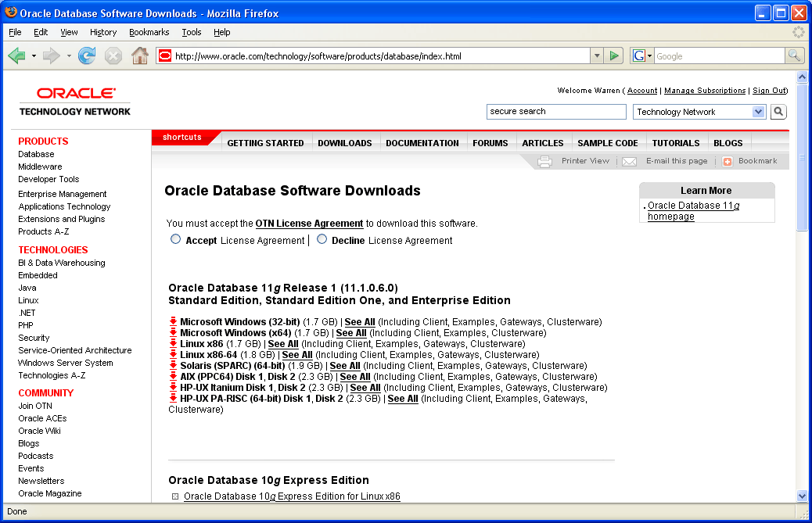  However, for Windows Vista, the only supported and qualified version is the Oracle Database 10g Release 2 (10.2.0.3) version. You can directly download Oracle for Vista by following the link below:  http://www.oracle.com/technology/software/products/database/oracle10g/htdocs/10203vista.html  After clicking the “See all” link for the Oracle Database 11g Release 1, 32-bit for Windows, the screen should look like this:  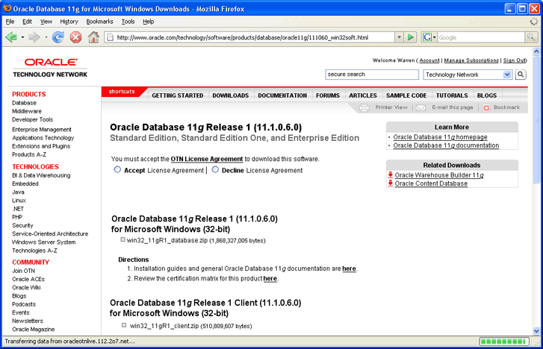  Click on the “OTN License Agreement” link at the top, and the following small window will appear.  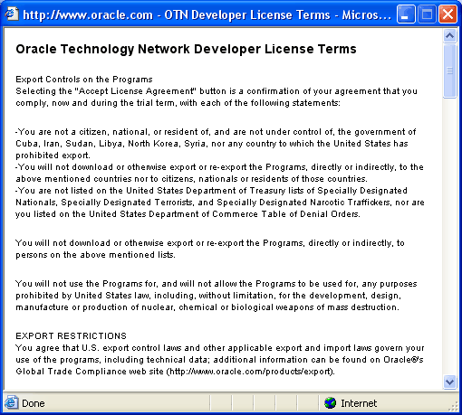  The screen contains export restrictions and the OTN license terms. Read the export restrictions. If anyone feels that they cannot accept this license agreement, please contact Jules for assistance.  After closing the window, if you agree with the license terms, you then click the Accept License Agreement radio button, at which point the text states “Thank you for accepting the OTN License Agreement; you may now download this software.”  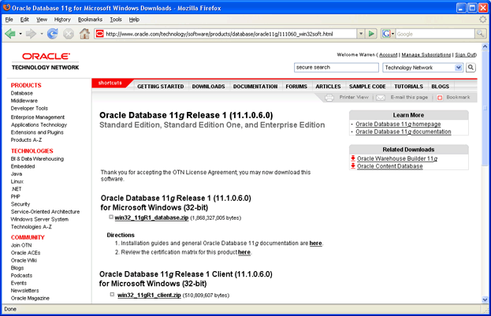  Click on the “win32_11gR1_database.zip” link under Oracle Database 11g Release 1 (11.1.0.6.0) for Microsoft Windows (32-bit). Doing so brings you to the next sub-step – saving the zipped installation file. You will see a screen similar to the following:

Save the Zipped Installation File | 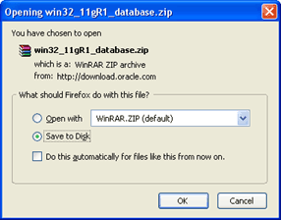  Create a directory for the download, such as C:\Oracle11g, make sure the “Save to Disk” radio button is selected, and then click OK in the screen above. You should see something like the following:  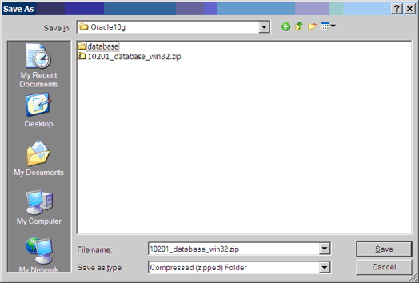  Click the Save button. Then you will see something like this:  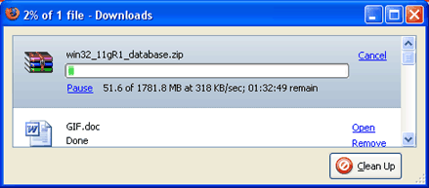  Sometimes a small file is transferred, and the download ends within a few seconds. If this happens it usually works to just try again, sometimes a few times, until a large download is underway. This is a full CD-ROM image, zipped, and will take anywhere from fifteen minutes to hours to download, depending upon the speed of your Internet connection.  The download for windows Vista is larger than 624 MB; in fact it is 800 MB. This is for a DVD and not a CD-ROM. It will take roughly 30 – 90 minutes to download using a DSL or broadband connection.  While you are waiting is a good time to turn off On-Access Scanning in MacAfee Antivirus and other antivirus (AV) programs that scan data that is accessed by the file system. On-access scanning will greatly slow some of the later stages of the installation. Your AV software may behave differently, but you should just be aware that some AV programs inject themselves in the middle of the large Oracle install file system data transfers. You may therefore want to adjust your AV configuration to shorten the install time. The install can succeed with on-access scanning enabled, but it will take a lot longer. Your perimeter AV defenses will not interfere with the install, and they should be left on.  Sometimes it happens that our downloads time out or otherwise fail. This usually has to do with the internet connection that we are using. If this happens repeatedly to the point where you are unable to obtain the zipped file in a timely manner, contact Chris Hutchison Jones (crhj@bu.edu) in the Computer Science Department, and he will arrange to overnight you a CDROM containing the same data as you were trying to download.  This is a good time to download a data-compression program. You will need WinZip, or a compatible program, to unzip the archive which you are downloading. If you do not already have it you can download either a full or evaluation copy from Winzip.com:  http://www.winzip.com/downwzeval.htmhttp://www.winzip.com/downwzeval.htm  The status indicator in the download window will indicate when the download is complete. You now have Oracle 11g on your hard drive, and you can log out from your Oracle OTN login.

Step 3: Unzipping Oracle

Introduction | The following instructions guide you through the sub-steps to unzip the zipped file that you just downloaded.

Unzip Oracle Installation File | If a zip program is present just click on Open, and it should launch. In WinZip the archive looks like this:  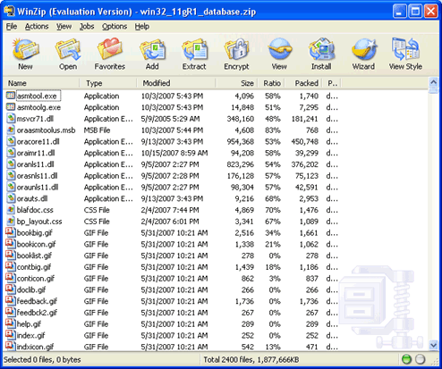  Yes, there really are 2400 files in the Oracle 11g Release 1 download. We are next going to extract all 2400 files into the same directory where we downloaded the zip file:  Click Extract in the toolbar at the top. You will see a window like the following. Navigate to the folder to which you downloaded the zip, as in this example:  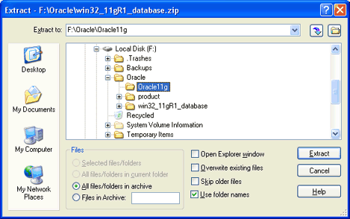  Then check that the radio button for All files/folders in archive is selected and that the Use folder names box is checked, as above. Then click Extract. You will see something like this:  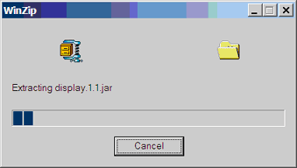  While this is extracting is a good time to take a look at the download directory that you created, such as C:\Oracle11g. It should look something like this in detailed view.  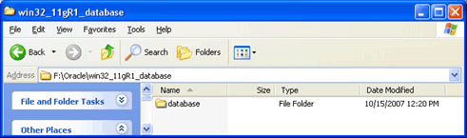  Notice that all of the Oracle 11g files are being unzipped under the database folder. The unzipped files will not be much bigger than the compressed zip files, because all of the larger files that are being unzipped are compressed jar files, and WinZip cannot compress them further.  After a few minutes the unzipping will finish, and you will have completed the download and unzipping of Oracle 11g. If you wish you can now copy all of the files in the database directory to a CD-ROM that you can then use to install Oracle or uninstall Oracle. If you are short of disk space you can then delete the file win32_11gR1_database.zip.

Step 4: Installing and Configuring Oracle

Introduction | This section contains step-by-step instructions for installing Oracle 11g from a CD-ROM or from the unzipped files on your hard disk. If you are short of disk space you can install directly from an Oracle installation CD-ROM, but it will be faster if you install from hard disk.  Before beginning the install you should download the latest Windows updates and close other applications on the machine. Closing other applications frees up resources for the install. If you have not done so already you should disable any on-access scanning in your antivirus software.

Install Oracle | Next launch the Oracle Installer.  Go to the database directory, or the CD-ROM, and click on the file setup.exe.  If the setup.exe program launches, but the Oracle installer doesn’t start after a couple of minutes, there may be a problem with your Java installation. Go to the install directory under database, and launch the setup.exe that you find there. This setup.exe often works when the other one doesn’t. When using Vista, be sure to run the setup as “Administrator” or a user with Administrative privileges.  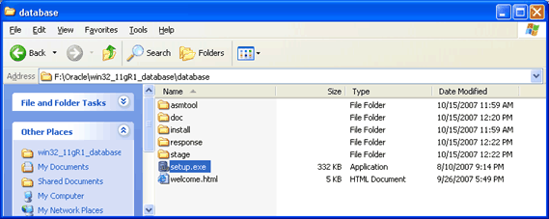  It may take several minutes for the Oracle Universal Installer to launch, during which time you will see a DOS-style text window reporting the checks before the launch. Then you will see a screen like the following. To choose the Oracle Home Location, browse to a directory where you want Oracle to put its files. There should be at least 2 GB of free space on this drive. In this example we chose Enterprise Edition for the Installation, to get the Enterprise Manager, which we use in CS674 Database Security.  Type in a simple Global Database Name. This name is called the Service ID or SID. The SID is used to form the names of other processes, so it is best to keep it short and alphabetic. Do not use the domain.name Global Database Name format unless you have a domain controller and static IP for Oracle, as you would likely have in a production Oracle installation. Use a simple “un-dotted” name such as ORCL instead. If you have more than one Oracle instance running on your machine, make sure that the Global Database Name (SID) is different for each instance. Type in and confirm a database password that you will remember. You will need this password later to create your user login, so you should write the password down. Keep the password simple. Security is not an issue for your student database, but forgetting your password can be a real problem if you can’t login to your database later. For class databases I recommend the memorable password “password”. If you don’t follow these instructions and later can’t remember your password see Appendix C for how to reset your SYSTEM password on Windows platforms without reinstalling Oracle. Make sure that Create Starter Database is checked. Then click Next.  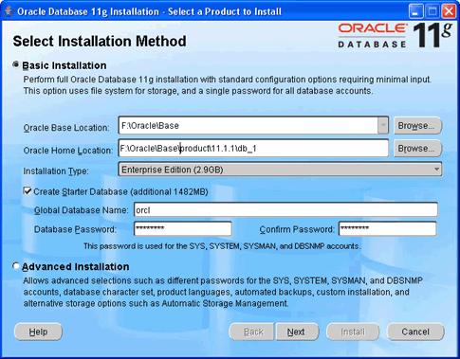  Then you will see the Product-Specific Prerequisite Checks, as below. If any of the checks are other than Succeeded, then there is something that you need to fix in your hardware or operating system before Oracle can be installed. Scroll down in the details scroll box until you see the detailed explanation for any prerequisite warnings, as below.  The example below shows a common problem, which is that your machine is configured without the Microsoft Loopback Adapter, which Oracle 11g requires. If you see this warning just go to Appendix A of this guide for instructions on installing the Microsoft Loopback Adapter. You don’t need to stop the installation to do this. You can install the loopback adapter and then click Back in the prerequisite check window to rerun the checks and continue the Oracle installation.  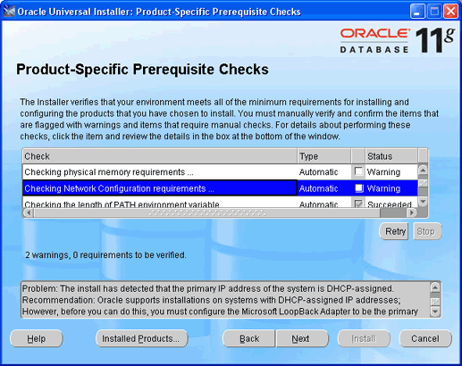  When the prerequisite checks have all succeeded, click Next, and you will see a Preparing to Install progress bar, and then the Oracle Configuration Manager Registration screen.  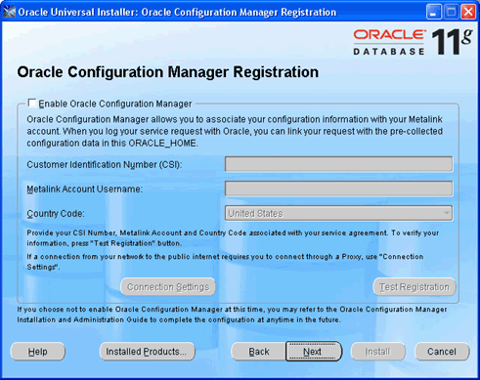  For the simple configuration you are using for this course, it is not necessary to enable the Oracle Configuration Manager. Leave the Enable Oracle Configuration Manager checkbox unchecked, and click Next to continue. You will see the Summary screen.  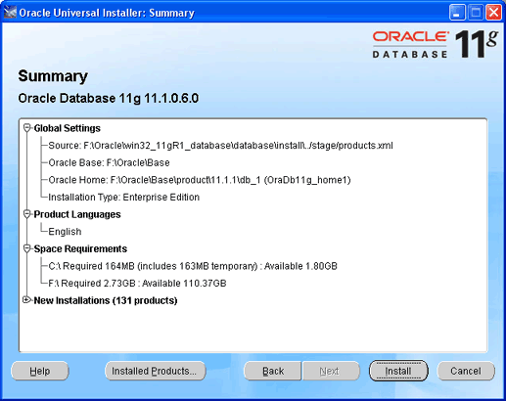  Next click Install.  You will then see the Install progress bar screen, as below. This is the main installation step, where the installer does many things to set up Oracle on your computer. This step will take fifteen minutes to an hour or so, depending on the speed of your computer. I usually try to glance over at the screen from time to time to see if there have been any exceptions that cause the Installer or Windows to ask me questions.  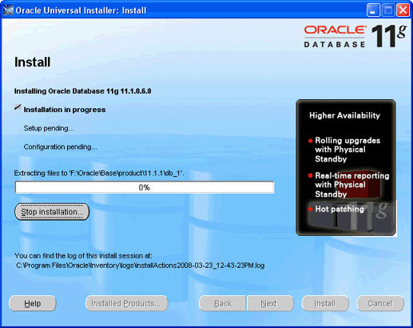  If you are really short of disk space you can delete the contents of the install directory once the install has completed, because once the install has completed Oracle no longer needs them.  You can easily burn an Oracle 11g database CD-ROM by navigating to the Disk1 directory, selecting all the files under Disk1, and writing them to a blank CD-ROM. As you might guess, there are additional Oracle install disks. Oracle has kindly packaged everything that we need for this class on Disk1.

Configure Oracle | When the main Install finishes The Oracle Installer will launch the Configuration Assistants window.  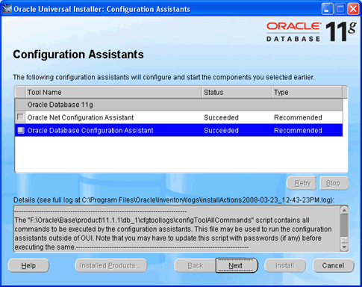  The configuration assistants are here launched by the installer, one at a time. You can run them separately later if you need to. You can select the assistants to run, or stop them from this screen, but it is best and easiest to just let them run. This stage usually takes fifteen to thirty minutes. If the Database Configuration Assistant takes a long time to run, check that your antivirus software isn’t interfering with the large file operations in this step.  If you see the following popup from Windows Firewall, just click Unblock. You may see this several times. Your machine will likely be very sluggish when the database creation assistant is running. This is normal.  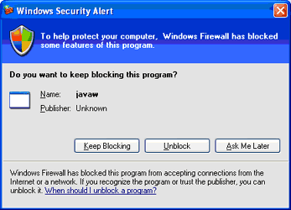  Eventually all assistants will complete, and you will see the following screen from the Database Configuration Assistant.  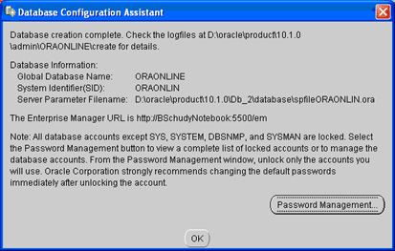  We don’t need Password Management now, because we will create our own accounts later in the next section.  Click OK.  You should now see the following screen indicating that all assistants have succeeded.  If they have not all succeeded, scroll through the log near the bottom to see what went wrong. If it seems that retrying will fix it, just select an assistant and click Retry. If it doesn’t work on retry don’t worry. Just contact your facilitator or instructor.  Click Next and you will see the following screen:  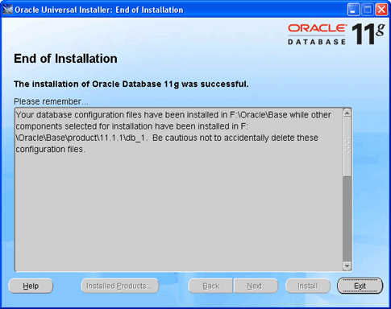  Click Exit and the installer will terminate.  The final step is connecting to our new Oracle instance, and creating a user.  - Go to:  - Start / All Programs/Oracle – OraDb11g_home1 / Application Development and launch SQLPlus.  Then fill in the username with SYSTEM, and type in the password that you entered during the install. You do not need to enter a Host String if your Oracle database is on the same machine as SQLPlus.  Then click OK.  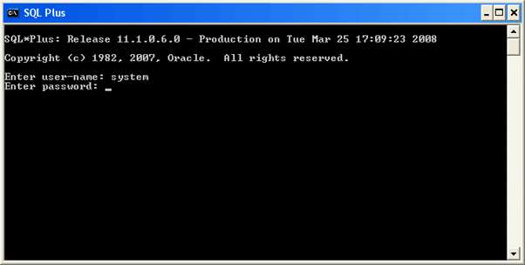  You should see a screen like the following:  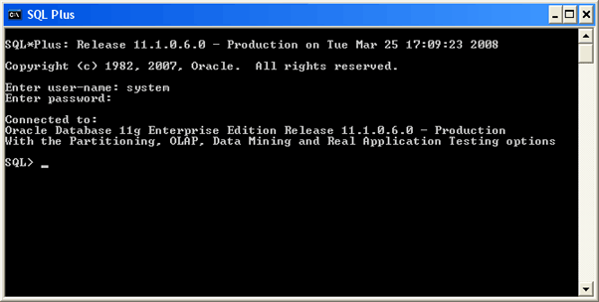  Congratulations! You have now successfully installed Oracle, started the database and connected to it with the SQLPlus client that we will use in this course.

Create Users | The SYSTEM account that we are now logged in under is the initial DBA account, and it has so many privileges that it is risky for routine use. We will next create an ordinary user of the sort that we will use for this class. I will call this user “JOE”, but you can substitute any name. Choose a password that you can remember. Just type in the following:  CREATE USER JOE IDENTIFIED BY JOEPASSWORD DEFAULT TABLESPACE USERS TEMPORARY TABLESPACE TEMP;  This SQL command creates user JOE with password JOEPASSWORD and sets up two important defaults for JOE’s account. Note the semicolon at the end. Upper case is conventional for SQL in the Oracle community, though for Oracle SQL case doesn’t matter except in quoted strings. When you have typed this command and hit return the screen should look like this:  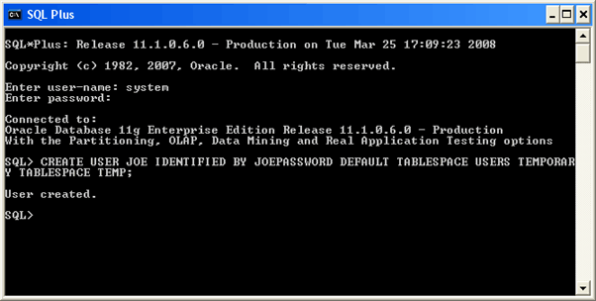

Connect To Oracle | Next we will give user JOE the privilege to connect to the database and the privilege to create database resources. Type  GRANT CONNECT, RESOURCE TO JOE;  Again, notice the semicolon at the end. Your SQLPLUS screen should now look about like this:  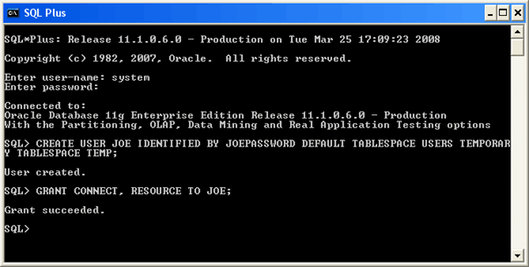  We will now disconnect as SYSTEM and connect as JOE, in one command. Type  CONNECT JOE;  Oracle will then ask you for JOE’s password. Enter JOEPASSWORD or whatever you provided in the IDENTIFIED BY clause when you created your user. Your SQLPlus screen should now look about like this:  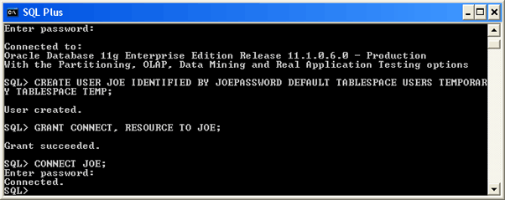  You are now connected to Oracle as an ordinary user, and you can do your exercises, experiment, or do whatever you want with Oracle. Have fun!  If you want to create another user, just connect as SYSTEM, and do what we did to create user JOE.
Congratulations! You are ready to work in Oracle.

How to Shut Down and Start Up Oracle
Your computer may become sluggish after installing Oracle. This can be normal when Oracle is running on a machine with limited resources. The sluggishness goes away when Oracle is stopped. You will need to have the Oracle instance running only a fraction of the time.

You can easily start and stop Oracle by starting and stopping the corresponding service. For an instance named SID, this service is called OracleServiceSID. Just right click on the service such as OracleServiceSID in the Services control panel and select Stop or Start. When the service is stopped it also stops the corresponding oracle.exe process, and when the service is started it also starts the process.

To get to the Services control panel in Windows, first open the Control Panel. If you are on Windows XP, it's easier if you click the Switch to Classic View look. Then on XP you can launch the services control panel by going to Start then Settings then Control Panel then Administrative Tools then Services. If you're on Windows 2000, it's already in classic view. In some cases, you may see a Services control right there in the control panel. If so, click on it and the services will come up. If you don't see Services, then you need to click on the Administrative Tools icon first. Then you will see Services and can click on that.

Once the services control opens, you will see a list of services. Highlight the one that says OracleServiceSID, where SID is the name that you gave your Oracle service when you installed Oracle. Then click Action/Stop. On Windows 2000, it may just be stop. At any rate, just find where "stop" is and click it, and wait a while the Oracle service shuts down the Oracle instance. Of course, once you stop it, Oracle is no longer running, so you'll have to repeat these steps and click "start" to start it again. Or, just rebooting your computer should make the service start again.

Configuring Oracle Startup Options

Your computer will boot more slowly when Oracle is running, because the Oracle services are starting at boot time, and starting an Oracle instance can take a while, particularly on a notebook computer.

You can configure Oracle so that it doesn’t start up when you boot your machine. Just open up the OracleServiceSID... service, as described above. But, instead of just clicking stop, you need to change the startup mode. Windows services have one of three startup modes -- automatic, manual, and disabled. By default, the Oracle service is in automatic mode. This means whenever you boot your computer, the service will start up automatically. You need to change it to manual to keep it from starting at boot time.

To do so, right click on the OracleServiceSID... service then click the Properties option. From there, you should see the startup mode, and be able to switch it from automatic to manual. Do the same to the OracleDBConsole service. Then next time you boot, those services won't start. Of course, if you set these services to manual startup mode, then when you need to use Oracle, you'll need to go into the services again and start them manually.

On recent Windows releases including XP you can also reduce the time to boot while leaving Oracle running by hibernating your computer rather than shutting it down and rebooting it. Restarting after hibernation will take a little longer with Oracle running, but not nearly as long as rebooting with Oracle in automatic startup mode.

Appendix A: Installing and Enabling the Microsoft Loopback Adapter
First, check if the Microsoft Loopback adapter is installed. On XP, from the Start menu, choose the Control Panel, then Administrative Tools, then Computer Management then Device Manager. A dialog box similar to the following should appear.

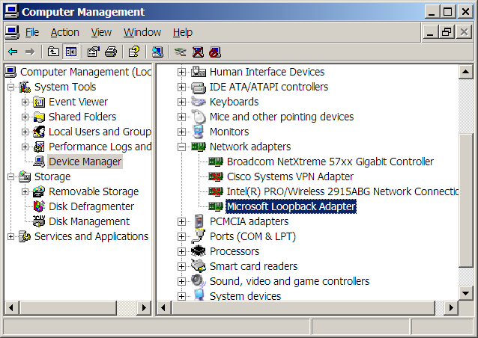

If the Loopback adapter is installed, it will appear there. If it is not installed then you need to install it. If it is installed, right click on Microsoft Loopback Adapter, and check that it is enabled. The right-click menu should include disable. If it includes enable, then you need to click on enable to enable the adapter. You can also do this through the Properties popup.
If the Loopback adapter does not appear in the dialog, install it by selecting Add Hardware in the Control Panel. The following dialog will appear:
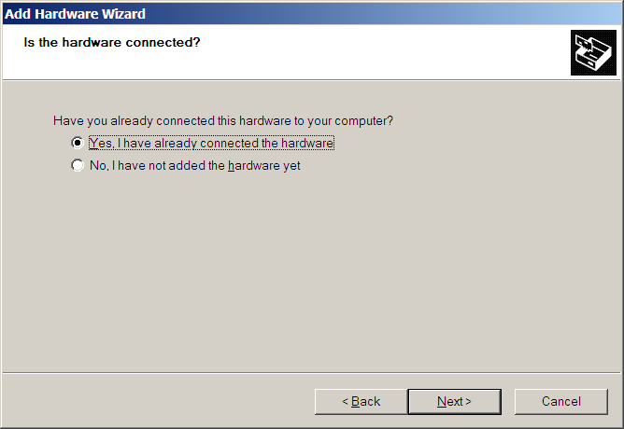
Select the Yes radio button and then Next. You will see a list of hardware already installed on your computer. Scroll down to the bottom of the list and select Add a new hardware device, and then click Next.
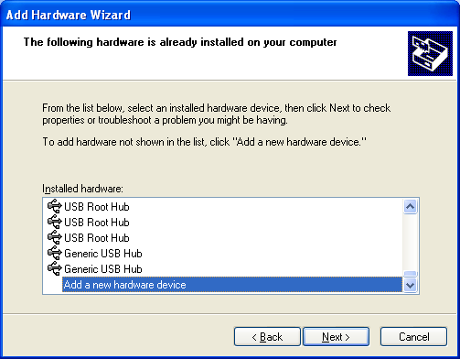
You will see a list of hardware already installed on your computer. Scroll down to the bottom of the list and select Add a new hardware device, and then click Next.
You will see the following screen. Select Search for and install… and click Next.
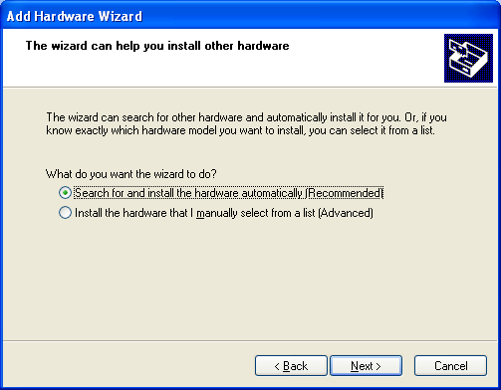
Select Network adapters then Next
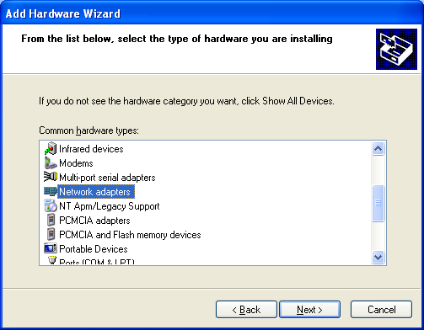

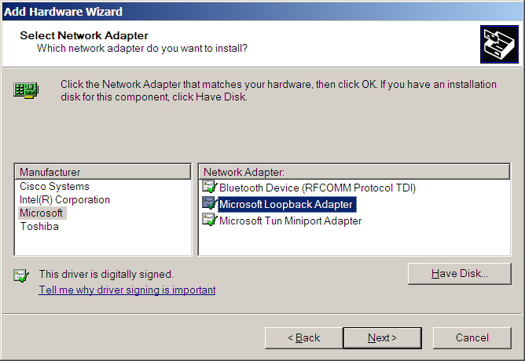

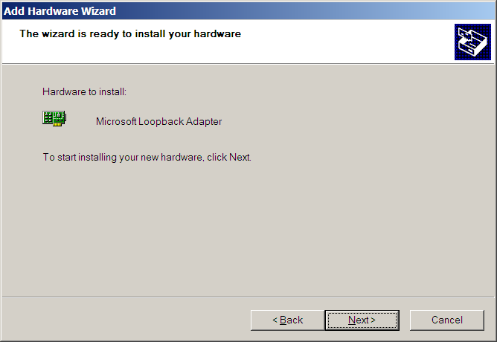
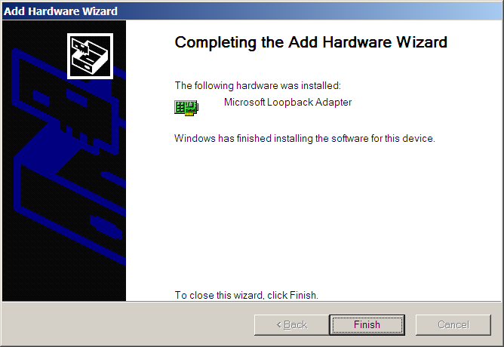

Check Control Panel->Network Connections. If the Loopback Adapter still does not say ‘Connected’ then do the following steps.
To manually install the Microsoft Loopback adapter in Windows XP, follow these steps:

- Click Start, and then click Control Panel.
- If you are in Classic view, click Switch to Category View under Control Panel in the left pane.
- Double-click Printers and Other Hardware, and then click Next.
- Under See Also in the left pane, click Add Hardware, and then click Next.
- Click Yes, I have already connected the hardware, and then click Next.
- At the bottom of the list, click Add a new hardware device, and then click Next.
- Click Install the hardware that I manually select from a list, and then click Next.
- Click Network adapters, and then click Next.
- In the Manufacturer box, click Microsoft.
- In the Network Adapter box, click Microsoft Loopback Adapter, and then click Next.
- Click Finish.

You next need to make sure that the Microsoft Loopback Adapter is properly configured.

- Right-click My Network Places on the desktop and select Properties. This displays the Network and Dial-up Connections control panel.
- Right-click the connection that was just created. This is usually "Local Area Connection 2". Select Properties.
- On the General tab, select Internet Protocol (TCP/IP), and click Properties.
- In the Properties dialog box, click Use the following IP address and do the following:
a) IP Address: Enter a non-routable IP address for the loopback adapter.
Oracle recommends the following non-routable address:
192.168.x.x (where x is any value between 0 and 255)
b) Subnet mask: Enter 255.255.255.0.
c) Record the values you entered.
d) Leave all other fields empty.
e) Click OK.
- Close the Network Connections window.

Note: On Linux systems, the loopback adapter is not required.

Appendix B: Installing Oracle 10g Express Edition
This appendix guides you though the installation of Oracle 10g Express on Windows and Linux. As of March 25, 2008, there is no Express Edition available for Oracle 11g. Note that Oracle Express is not compatible with Microsoft Vista.

Introduction
The Express Edition (XE) is a limited scalability version of Oracle designed to compete with comparable reduced scalability DBMS from Microsoft and other vendors. It has the following limitations:

- Only one CPU may be used (on multiple CPU systems, the equivalent of one CPU is used)
- No more than 4GB of user data may be stored
- Only one instance of XE may be run at one time
- XE will use at most 1GB of RAM during execution

Despite these intended scalability limitations, XE is ideal for classroom work because it requires fewer system resources, yet is functionally complete enough that it may be used for the exercises in CS579, CS669, and CS779. CS674 requires the Enterprise Manager, which is in the Enterprise Edition.

Requirements
This package has minimum requirements for operating system versions:

- Windows 2000 Service Pack 4 or later
- Windows Server 2003
- Windows XP Professional Service Pack 1 or later
- For Linux, kernel 2.6 is required.

Both Windows and Linux installations require approximately 1.7GB of disk space. At least 512MB of memory is recommended. Oracle Express Edition is not supported on Microsoft Windows Vista is not supported; if you have Windows Vista please only install the supported and qualified version of Oracle 10g Release 2 (10.2.0.3).

Installation (Windows)
The following is taken from the Oracle 10g Express Edition Installation Guide.
To perform a graphical user interface installation:
- Log on to Windows with Administrative privileges.
You must be part of the Administrators group on Windows to install Oracle Database XE. If you are logged in as a domain user, ensure that you are connected to the network.
- If the ORACLE_HOME environment variable has been set, then use System in the Control Panel to delete it.
- Go to the following Web site:
http://www.oracle.com/technology/products/database/xe
- Click Free Download and follow the instructions to select and download the Microsoft Windows version of Oracle Database XE Server.
- After downloading the Oracle Database XE installation executable, OracleXE.exe (for the Western European character set) or OracleXEUniv.exe (for the Universal character set), double-click it.
"Oracle Database XE Character and Language Configurations" describes these character sets in detail.
- If you are installing over an existing Oracle Database XE installation, then click Repair and then select Next.
The Repair option appears only if you are reinstalling the same version of Oracle Database XE. If you are installing a newer version of Oracle Database XE, you must first deinstall the earlier version before installing the new version. In this case, the deinstallation removes the database of the earlier version. If you want to save its data before proceeding, refer to Oracle Database Express Edition 2 Day DBA for information on backing up the database.
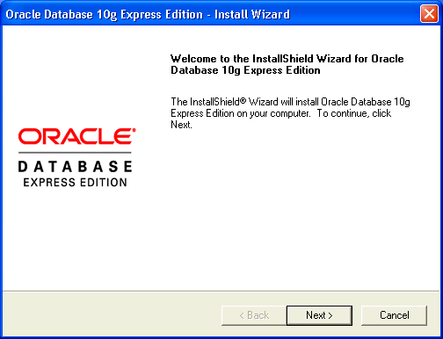
- In the Oracle Database 10g Express Edition - Install Wizard welcome window, click Next.
- In the License Agreement window, select I accept and then click Next.
- In the Choose Destination Location window, either accept the default or click Browse to select a different installation directory. (Do not select a directory that has spaces in its name.) Then click Next.
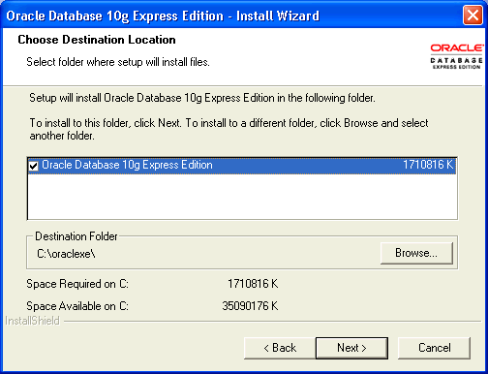
- If you are prompted for a port number, then specify one.
The following port numbers are the default values:
  - 1521: Oracle database listener
  - 2030: Oracle Services for Microsoft Transaction Server
  - 8080: HTTP port for the Oracle Database XE graphical user interface
If these port numbers are not currently used, then the installation uses them automatically without prompting you. If they are in use, then you will be prompted to enter an available port number.
- In the Specify Database Passwords window, enter and confirm the password to use for the SYS and SYSTEM database accounts. Keep these simple and write them down, because you will need them again. Then click Next.
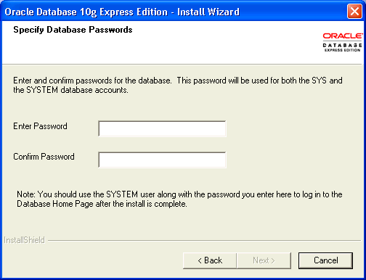
- In the Summary window, review the installation settings, and if you are satisfied, click Install. Otherwise, click Back and modify the settings as necessary.
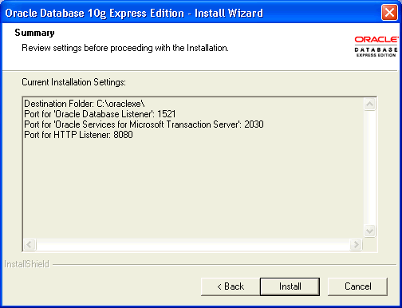
- In the InstallShield Wizard Complete window, to display the Database Home Page, click Launch the Database homepage. Then click Finish.
- The database hope page will open in your browser, as below. Type in your SYSTEM username and the password that you provided when you installed. Then click Login.
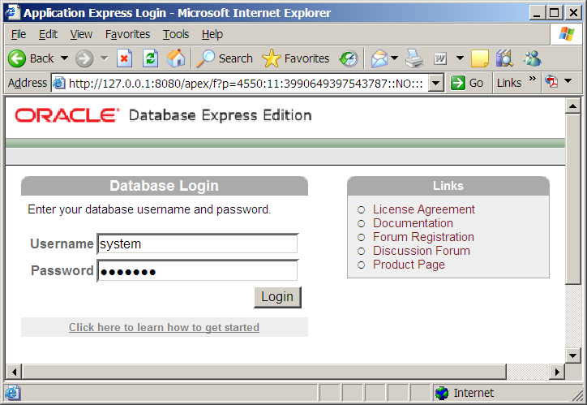

Installation (Linux)
To install Oracle Database XE Server:
- Log on to your computer with root permissions.
- Go to the following Web site:
http://www.oracle.com/technology/products/database/xe
- Click Free Download and follow the instructions to select and download the Linux version of Oracle Database XE Server.
- Run one the following Oracle Database XE executables to either install or upgrade Oracle Database XE server:
  - For Linux operating systems that use Debian:
    - Universal character set: oracle-xe-universal_10.2.0.1-1.0_i386.deb
    - Western European character set: oracle-xe_10.2.0.1-1.0_i386.deb
  - For all other supported Linux operating systems:
    - Universal character set: oracle-xe-univ-10.2.0.1-1.0.i386.rpm
    - Western European character set: oracle-xe-10.2.0.1-1.0.i386.rpm
For example, if you downloaded the oracle-xe-universal_10.2.0.1-1.0_i386.deb executable into a directory called downloads, you would enter the following command:
$ dpkg -i downloads/oracle-xe-universal_10.2.0.1-1.0_i386.deb

If you downloaded the oracle-xe-univ-10.2.0.1-1.0.i386.rpm executable, you would enter this command:
$ rpm -ivh downloads/oracle-xe-univ-10.2.0.1-1.0.i386.rpm

The installation displays a status of its progress.
- When prompted, run the following command:
$ /etc/init.d/oracle-xe configure

- Enter the following configuration information:
  - A valid HTTP port for the Oracle Database XE graphical user interface (the default is 8080)
  - A valid port for the Oracle database listener (the default is 1521)
  - A password for the SYS and SYSTEM administrative user accounts
  - Whether you want the database to start automatically when the computer starts
If you enter Yes, then the database starts immediately
If you need to change the configuration settings, then you can do so by running the following command:
$ /etc/init.d/oracle-xe configure

To start the database manually, run this command:
$ /etc/init.d/oracle-xe start

To stop the database manually, use the following command:
$ /etc/init.d/oracle-xe stop

Starting the Database (Windows and Linux)
The following is taken from the Oracle 10g Express Edition Installation Guide.
After you have installed Oracle Database XE, the database is up and running and you can begin using it right away. To start using Oracle Database XE, you can go to the Database Home Page in the Oracle Database XE graphical user interface.
Immediately after you install Oracle Database XE using the graphical user interface installation method, if you selected the Launch the Oracle Database 10g Express Edition homepage checkbox when the installation completed, the Database Home Page appears. To get started using Oracle Database XE, click Getting Started to learn how to log on and create a simple application.
If you did not select the Launch the Oracle Database 10g Express Edition homepage checkbox, or if you want to access Oracle Database XE from another computer, then follow these steps:
- To access the Database Home Page, from the Start menu, select Programs (or All Programs), then Oracle Database 10g Express Edition, and then Go to Database Home Page.
If Oracle Database XE Server is installed on another computer, then you can access it from the following URL:
http://host:port/apex/

In this URL:
  - host is the host name or IP address of the computer where Oracle Database XE Server is installed. If Oracle Database XE Server is on your local computer, then you can enter localhost as the host name.
Note that the URL in the browser by default points to the localhost IP address 127.0.0.1. If you want another user to access your Oracle Database XE installation, then provide the host name or IP address of your computer.
  - port is the TCP port that the Oracle Database XE HTTP listener is listening on. You set this port number during installation. Normally it is set to 8080.
For example, if Oracle Database XE Server was installed on a computer with the host name shobeen with the default port number 8080, you would access the Database Home Page at this URL:
http://shobeen:8080/apex/

- Log in to the database using the user name SYSTEM, and supply the password that you created during installation.
The web interface provides a Help link that displays commonly used commands.

Appendix C: How to reset your SYSTEM password on Windows

This appendix provides instructions for resetting your Oracle SYSTEM password without reinstalling Oracle. This method uses the operating system authentication, which must be enabled for this to work. We will login to Oracle using the SYSDBA account for which operating system authentication is turned on by default for operating system users in the “dba” user group. Users with the administrator privilege on MSWindows are usually in the dba user group. This solution depends upon having SQLPlus or another comparable Oracle client installed on the machine.
If you are running on a Microsoft Windows platform and you are logged onto the machine as a user in the "dba" operating system user group, which Oracle creates, you don't need to specify a password to connect as sysdba. Just go to the DOS (Command line) prompt and run "sqlplus / as sysdba". SQLPlus should be launched in the command line interface, connected to Oracle as SYSDBA. You can then change the SYSTEM password with the command:
ALTER USER SYSTEM IDENTIFIED BY <new password>;

Where <new password> is replaced by the new password that you wish to give to the SYSTEM user. For a class installation choose something memorable, and write it down or store it on your computer. Production passwords should be carefully chosen to be resistant to attacks and the passwords should be carefully protected.

After you have changed the SYSTEM password to something that you know, you can connect as SYSTEM, and do anything that you wish, including changing any passwords.
There are similar ways of connecting to Oracle if you know the root password on UNIX family platforms.

